Fine Art Paint Parties!
at City Lights Art Gallery

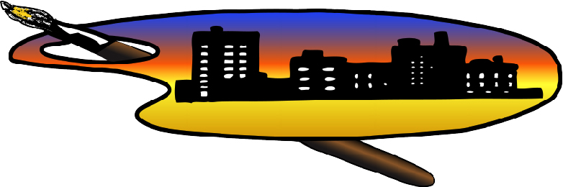

Are you bursting with creativity but lack the know-how, the materials and/or the location to paint? Want a fun evening with your friends doing something totally out of the ordinary?

City Lights Art Gallery is now hosting paint parties for up to 10 participants! You bring your friends. We provide the blank canvas, the paints, the brushes and the refreshments!

The artists at City Lights will guide you and your group through a fun art piece using acrylic paint on canvas. Nothing like painting in an art gallery for inspiration!

Cost is $35 per person and includes all art materials and refreshments.

Reserve your space now for Saturday, August 15th or Saturday, August 22nd from 6-9 pm.

Beginning in September, we will host a Fine Art Paint Party every 2nd and 4th Saturday. Call City Lights Art Gallery at 702.260.0300 or email us at citylightscoop@centurylink.net for reservations or any questions.
- - - - - - - - - - - - - - - - - - - - - - - - - - - - - - - - - - - - - - - - - - - - - - - - - - - - - - - - - - - - - -

City Lights Art Gallery
P.O. Box 91314-1314 3 E. Army Street
Henderson, NV 89009-1314 Henderson, NV 89015-7248
702.260.0300 citylightscoop@centurylink.net www.citylightsartgallery.com

